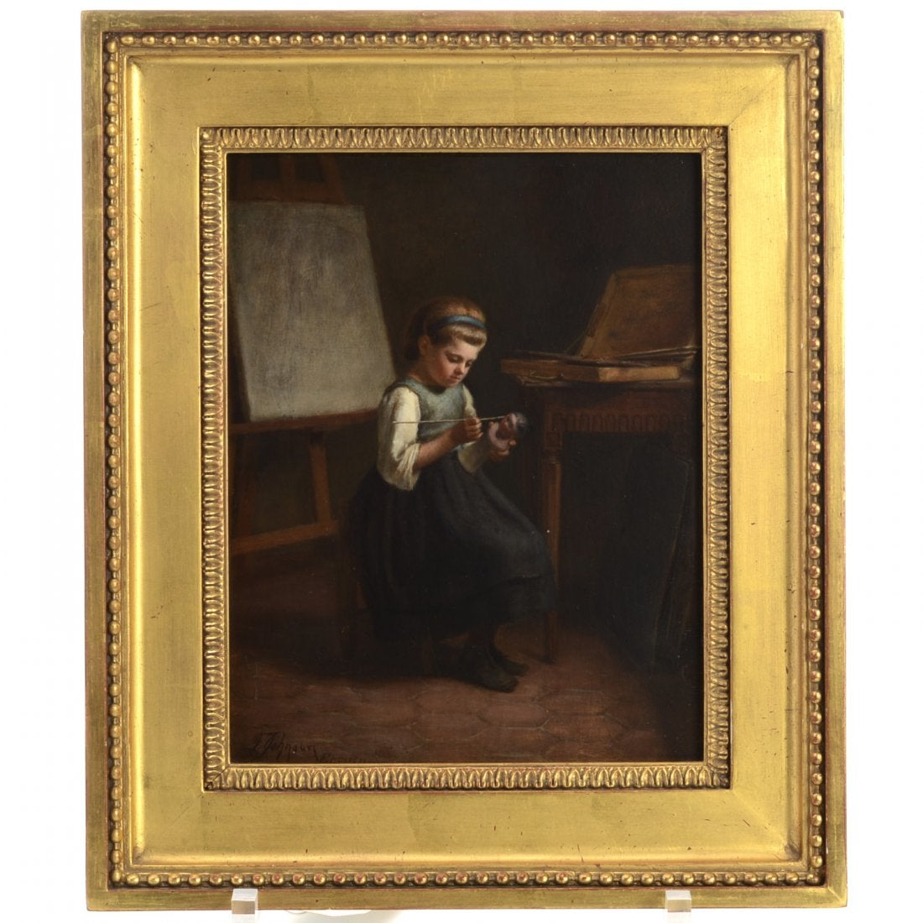 Samuel Frost Johnson, 700 $ US, Vendu le 15 Avril 2016

Samuel Frost Johnson, painting, Samuel Frost Johnson (American, b. 1835), "The Little Puppet Maker", c. 1865, oil on panel, signed and inscribed "F. Johnson, Ecouen", lower left, 9.75"h x 7.5"w (sight), gilt frame

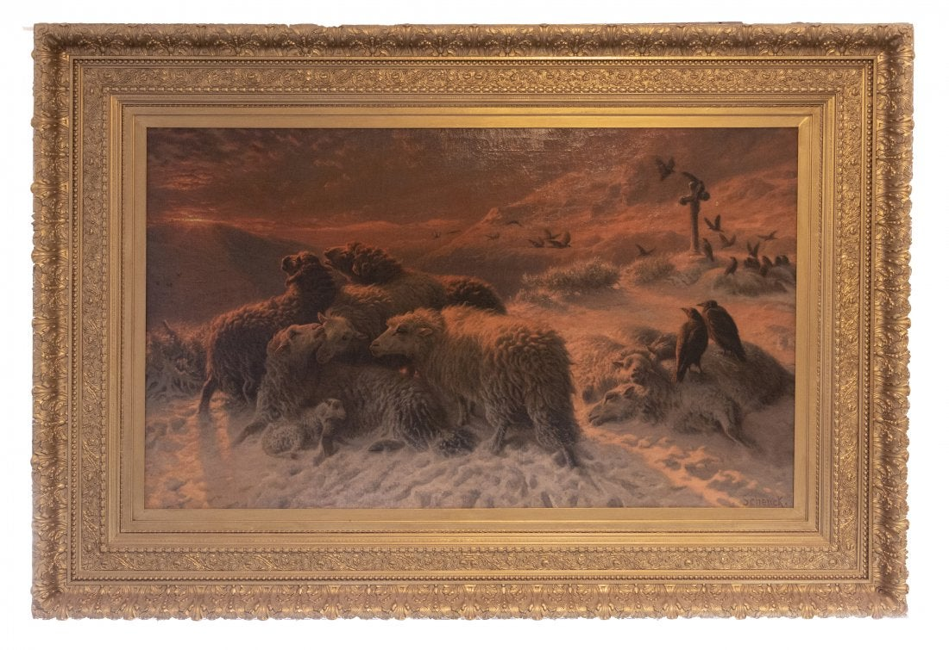1700 $ US, Vendu le 9 Janvier 2020
Oil on canvas. 65.5x140 cm (25¾x55"); in frame of cast plaster, wood, and gold leaf: 131x185 cm (51½x72¾"). Included is an archive of autographed signed letters by Schenck to Mrs. B.B. Tuttle and receipts for paintings purchased.

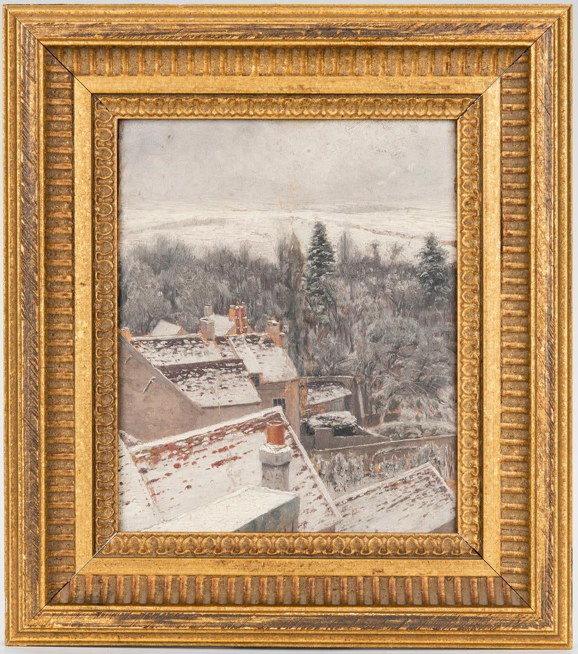550 $ US, Vendu le 25 Janvier 2020

James William Pattison (Illinois/Missouri/Massachusetts/North Carolina/France, 1844-1915) oil on board winter landscape painting titled "View From His Studio at Ecouen, [Paris]" depicting rooftops dusted with snow, foreground, bare trees and evergreens, middle ground, and a field below a grey sky, background. Signed "J.W. Pattison", titled, and dated "1876" en verso of board. Paper label with artist biographical information, en verso of frame. Housed in a molded giltwood frame with lamb's tongue rabbet edge. Sight - 8 5/8" H x 7 1/4" W. Framed - 13 1/2" H x 12" W. Third quarter 19th century. Provenance: The collection of Dr. William Kendall Striker, Chattanooga, TN. Biography: Pattison enlisted in the Union Army late in the Civil War and began his art career as an illustrator for Harper's Weekly. He then concentrated on painting and was a student of James M. Hart and George Inness. He taught at Washington University (1869-1873), where William Merritt Chase was one of his students. His earliest painting landscapes were in the Hudson River School style; one example is Twin Lakes, Leadville, Colorado (1872; Vose Galleries). Later Pattison studied in Dusseldorf and Paris. With his wife Helen Searle (1830-1884), Pattison lived for six years at Ecouen, just north of Paris, which was the home of an artists' colony. There he took instruction in landscape painting from Luigi Chialiva, who was well known as an animal painter. Pattison exhibited in the Paris Salons of 1879-81. He returned to America in 1882 or 1883 and was active in Chicago art organizations, including the Cliff Dwellers, the Palette and Chisel Club, and the Chicago Municipal Art League. He was director of the School of Fine Arts in Jacksonville, Illinois (1884-1896) and taught at the School of the AIC in 1896. Between 1897 and 1906 Pattison worked in the Tree Studio Building. Pattison exhibited at the World's Columbian Exposition in 1893 and at the St. Louis Universal Exposition, eleven years later. His work appeared at the Art Institute's annuals between 1891 and 1910. He was also an editor and art critic for the Fine Arts Journal, and he is the author of "The World's Painters Since Leonardo", published in 1904. (adapted from Clute, Walter Marshall. "James William Pattison: Author, Critic and Painter." The Sketch Book 5 (May 1906): 311-317; Clarkson, Ralph. "Chicago Artists: Past and Present." Art and Archaeology 12 (September - October 1921): 129-144; Sparks, Esther. "Biographical Dictionary of Illinois Painters and Sculptors, 1808-1945." Diss., Northwestern University, 1971, pp. 546-547; Askart).

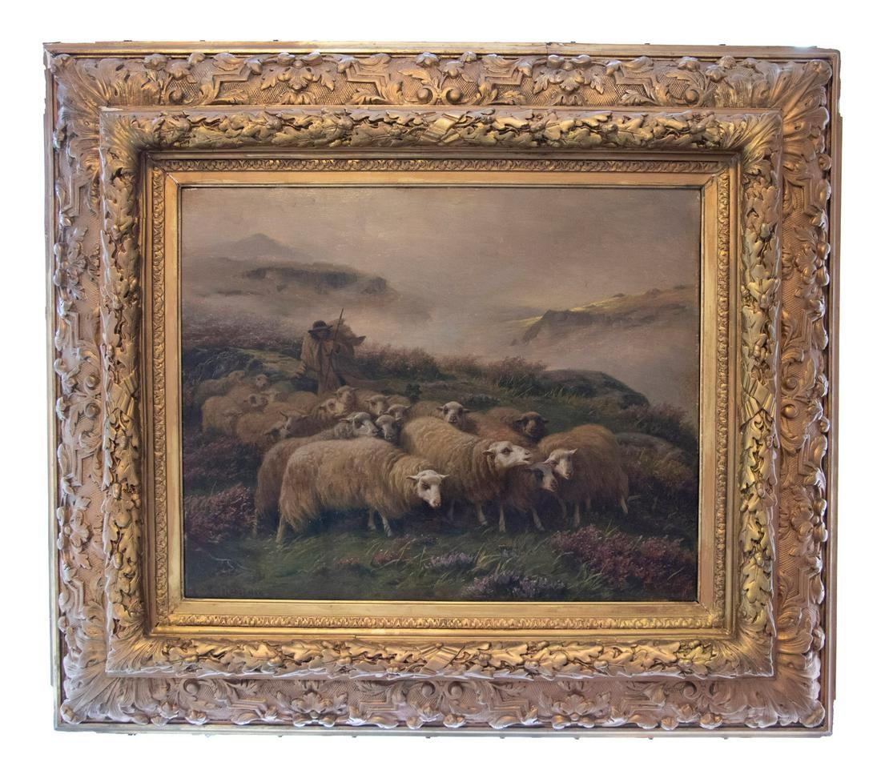500 $ US, Vendu le 9 Janvier 2020
Oil on canvas. 39x43.3 cm (15¼x17"); in frame of cast plaster, wood, and gold leaf: 69x78.5 cm (27¼x31").
Signed by the artist. August Friedrich Schenck was a Danish-born artist who spent most of his career in Ecouen, France after Schleswig-Holstein acceded to the German Confederation. He specialized in romantic pastoral scenes reminiscent of his most famous painting, Anguish, which was exhibited at the Salon of Paris in 1878 and is now in the collection of the National Gallery of Victoria, Melbourne.

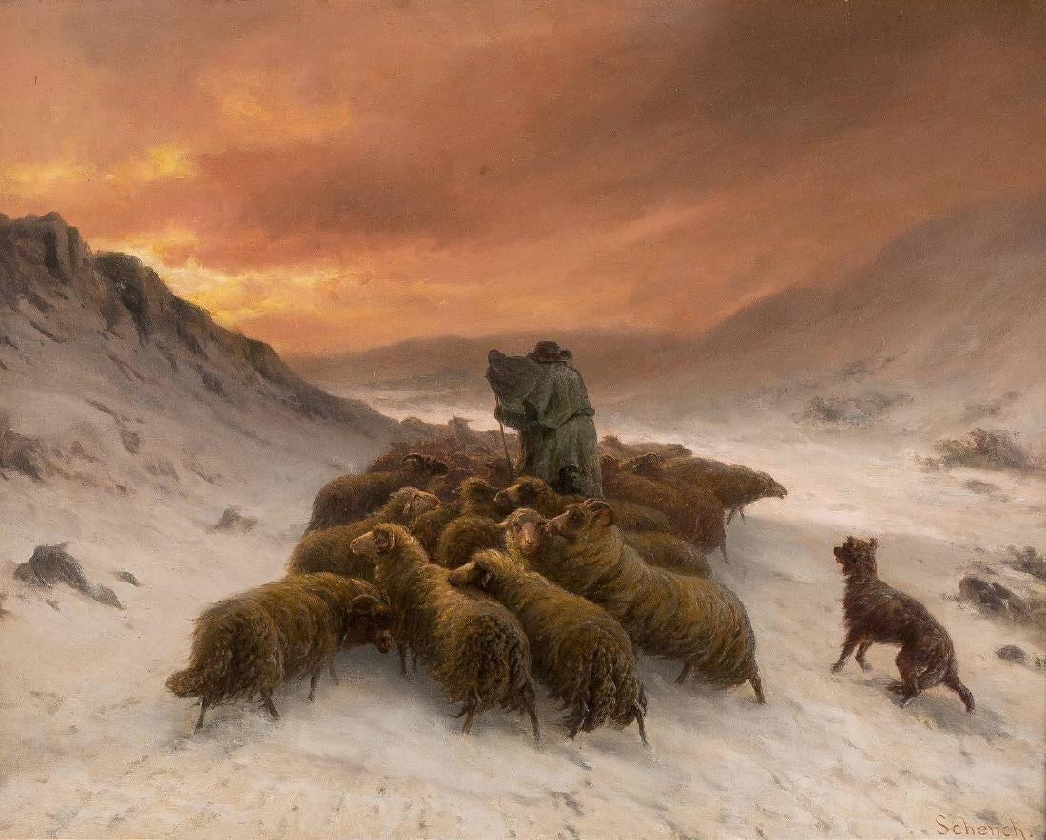
1200 $ US, Vendu le 23 Sept 2017
AUGUST FRIEDRICH ALBRECHT SCHENCK 1828 Glücksstadt - 1901 Ecouen (Seine-et-Oise) SCHAFHERDE IM SCHNEE Öl auf Leinwand. 65 x 81,5 cm. Signiert unten rechts 'Schenck'. Rahmen.

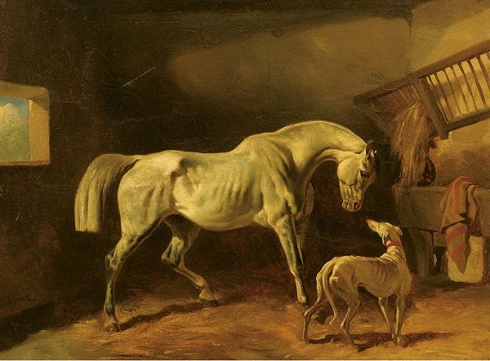

2750 Euros, Vendu le 29 Nov 2008
Gluckstadt 1828 – Ecouen 1901. La stalla, olio su tela, cm 64x81firma in basso a sinistra: Schenck

Dans votre liste de peintres, il n’y a pas Joseph Pressmane

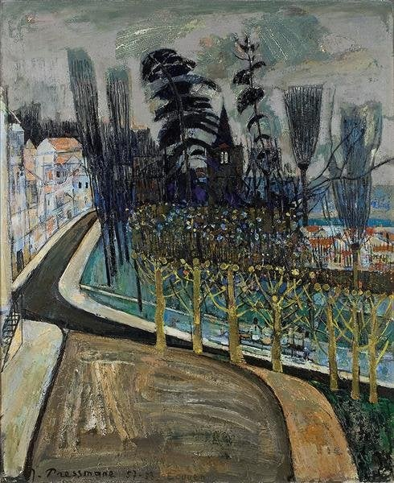

Joseph Pressmane, 7500 $ US, Vendu le 18 Mai 2008
Square d`ecouen, 1957-58, oil on canvas, 73 X 60 cm., signed and dated lower left.

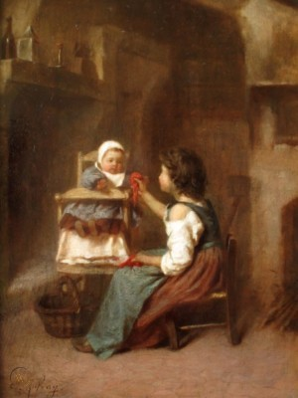
JOSEPH AUFRAY (1836-1885) FRENCH GENRE OIL to $15,000+ PROV: BONHAMS £4,000 - £6,000 GBP - SIGNED PANEL JOSEPH AUFRAY (1836-1885) FRENCH GENRE OIL to $15,000+ PROV: BONHAMS £4,000 - £6,000 GBP - SIGNED PANEL JOSEPH ATHANASE AUFRAY ( 1836 - 1855 ) A stunning oil by Joseph Aufray the French 19th century genre painter. This work was originally with Bonhams London in 2006 Est £4,000 - £6,000 GBP. We have since had it cleaned and it is now in super condition in its original frame. Aufray is highly collected and always makes very strong prices - this work is a superb example - fully signed, on panel and in its original frame - dating to around 1880. It has been in a museum at some pint but the label has rubbed away. Title: "Feeding Baby" Signature: Signed lower left Provenance: Bonhams, Bond Street, London / Old museum label verso. Size: Measures c. 13 x 10 inches unframed / framed c. 23 x 20 Frame: Original gilt and ebony frame with some very minor marks Condition: Super ABOUT THE ARTIST: Joseph Aufray was a French painter of genre subjects born in Paris on 4 April 1836. He studied under Barrias, and then later moved to Ecouen, near Paris. ‘Childhood’ was a subject of which Aufray had a magical understanding. He portrayed a happier and more innocent view of the 19th Century, providing the perfect atmosphere for this extremely popular subject. This popular artist exhibited regularly at the Paris Salon between 1865 and 1876, and his last exhibit was a Portrait of a Lady in 1885. In 1873 he exhibited several works at an exhibition in Cologne, also exhibiting in London in 1876. : English Scottish Irish Welsh French Watercolor Watercolour Oil on Canvas Victorian Listed Superb 19th century Exhibited Royal academy Institute Dowdeswell Agnew Cooling Watercolourists Sothebys Christies Bonhams dog landscape 18th Century 18thC Marine RSA RSW ROI RBA RWS SS provenance luminist American rhode island Chicago new york bo: English Scottish Irish Welsh French Watercolor Watercolour Oil on Canvas Victorian Listed Superb 19th century Exhibited Royal academy Institute Dowdeswell Agnew Cooling Watercolourists Sothebys Christies Bonhams dog landscape 18th Century 18thC Marine RSA RSW ROI RBA RWS SS provenance luminist American rhode island Chicago new york

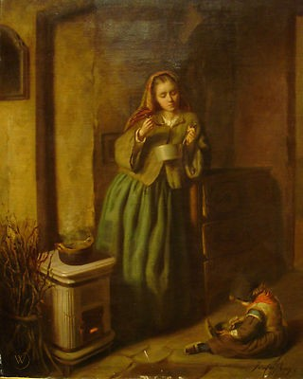

Mother and Child , 19th Century French School by Joseph Athanase AUFRAY (1836-c.1885) sales to £15,000 - exhibition label verso Fine 19th Century French School interior scene of a mother and child, oil on canvas by Joseph Aufray. Exceptionally fine interior scene of a mother cooking as a child plays on the floor. Leading example of Aufray's work exhibiting defined interiors (see the white stove, kindle saucepan and draws) very good detail to the attire and faces. Bittersweet scene showing the humble dignity of French life of the lower classes. Excellent condition, presented in a superb antique gilt frame. The Artist Joseph Aufray was a French painter of genre subjects born in Paris on 4 April 1836. He studied under Barrias, and then later moved to Ecouen, near Paris. ‘Childhood’ was a subject of which Aufray had a magical understanding. He portrayed a happier and more innocent view of the 19th Century, providing the perfect atmosphere for this extremely popular subject. This popular artist exhibited regularly at the Paris Salon between 1865 and 1876, and his last exhibit was a Portrait of a Lady in 1885. In 1873 he exhibited several works at an exhibition in Cologne, also exhibiting in London in 1876.Measurements : 29" x 25" Framed Why Buy From Surrey Fine Arts? Our paintings are carefully selected based on their quality, age, condition and historical importance. Surrey Fine Arts only sell original period/antique oil paintings. We understand your purchase for your home or as an investment is important and we are more than happy to help with any questions even long after you have received your painting. We are happy to send our paintings anywhere in the world regardless of value or size and are happy to work with our buyers to make sure they receive their item quickly and safely. We offer extremely low international Express postage often arriving to the USA, Russia and China within 48 hours. We also offer options for buyers to avoid needless customs charges. Our collection comes from various sources including private estates, auction houses, galleries, museums as well as our own paintings that are circulated out & many of which are new to the market. As well as our own expertise at Surrey Fine Arts many of our works of art are assessed and authenticated by leading UK and International specialists in their field.

